# Ideation Phase Empathize & Discover

|  |  |
| --- | --- |
| Date | 14 October 2022 |
| Project Name | AI-powered Nutrition Analyzer for Fitness Enthusiasts |
| Maximum Marks | 4 Marks |

## Empathy Map Canvas:

An empathy map is a simple, easy-to-digest visual that captures knowledge about a user’s

behaviours and attitudes.

It is a useful tool to helps teams better understand their users.

Creating an effective solution requires understanding the true problem and the person who is experiencing it. The exercise of creating the map helps participants consider things from the user’s perspective along with his or her goals and challenges.

## Example:

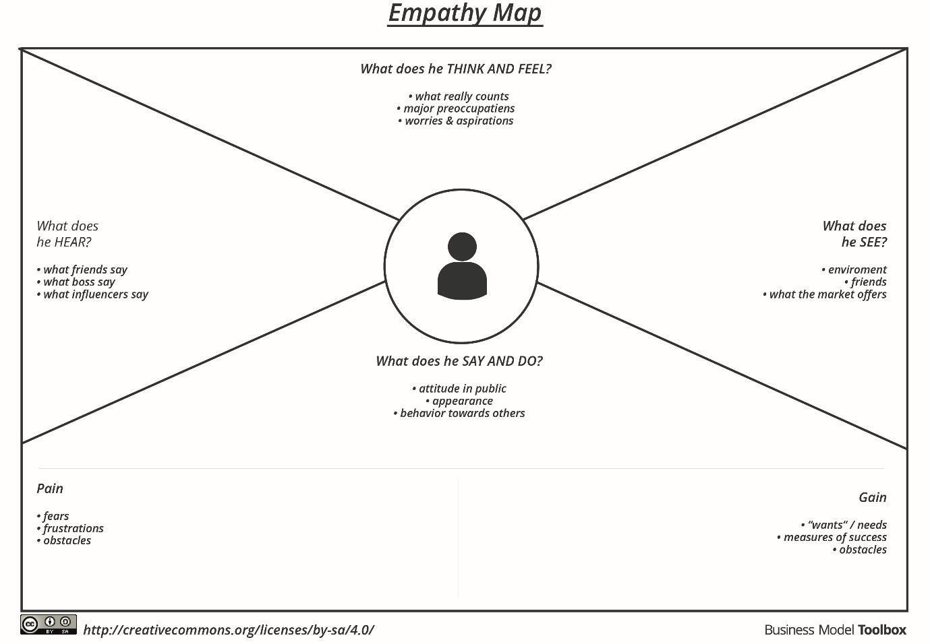

Reference: <https://www.mural.co/templates/empathy-map-canvas>



# Empathy Map Canvas

1 Example:

AI-powered Nutrition Analyzer for Fitness Enthusiasts

Amazing

Variety of Options

Lots of Recommandation

I cannotfind which is product is best one

It covers the foundation of Agile methodologies

It includes data science tools

Can find that product that are similar to many brand of products

Comparing with local products

Buying best product in low cost

Research about it before buying

Products with more variety

Recommending products based on latest search

Difficult to ask Refund

All kinds of trends and culture products

Fitness Enthusiasts

Lack of consistency beteen brands

Product Qualitycan be only assured by the seller

Appling for refund or exchange frequently

Users requesting for cash n delivery

Need to assurance for the product quality

Personalization and fit

Better for Self Reliance

Users satisfication on products